20/10/2015 | 93.  - Additional Email Attachments & Emails / Issue:  1. 93  lorraine32@blueyonder.co.uk_10.20.2015_RE SIMON CORDELL  20/10/2015  / Page Numbers: 700,701  --  700,  From: Lorraine Cordell  lorraine32@blueyonder.co.uk>  Sent: 20 October 2015 17:48  To: 'Forster, John  Subject: RE: SIMON CORDELL  Dear Mr. Dear Forster  Could you please put this email in front of the legal adviser, the alleged erroneous entries on my PNC as you have put it, are made up from the court as the police would not be able to put records on a person’s PNC record without a case being put in front of the courts.  My Mother has asked the court to check all the registries at the court against the records the police hold on my PNC record. This showed the errors and as you said to my mother at the court if a case is not listed at the court, then it was never heard at the court.  There are 5 errors of no listing on my PNC that the court does not have in the court register how can this be?  My mother has been to the police who do not want to address this issue therefore she came to the court as the court should hold all records.  By the legal adviser not wanting to write a letter showing my records have been checked by the court what is this saying. why should a person be able to ask the court to check their records, yet the court does not want to get involved in errors they found?  This is a miscarriage of justice; the court has not found records in the court registries that are on my PNC record, yet the court does not want to do anything about it.  Regards  Simon Cordell  From: Forster, John mailto: john.forster@hmcts.gsi.gov.uk  Sent: 20 October 2015 16:03  To: lorraine32@blueyonder.co.uk  Subject: SIMON CORDELL  Dear Mr. Cordell,  Further to your request for a letter from the court regarding the alleged erroneous entries on the PNC, the legal adviser has stated that the court cannot supply this information: you must make your request through the police.  Regards,  Customer Services Unit (8)  Highbury Corner Magistrates Court 51 Holloway Road LONDON N7 8JA  701,  DX: 153700 Highbury 4  Tel: 0207-506 3109  e-mail: gl-hcornermcenq@hmcts.gsi.gov.uk  Gold fax: 0870 739 5768  I am neither authorised to bind the Ministry of Justice contractually, nor to make representations or other statements which may bind the Ministry of Justice in any way via electronic means.  This e-mail (and any attachment) is intended only for the attention of the addressee(s). Its unauthorised use, disclosure, storage, or copying is not permitted. If you are not the intended recipient, please destroy all copies and inform the sender by return e-mail.  Internet e-mail is not a secure medium. Any reply to this message could be intercepted and read by someone else. Please bear that in mind when deciding whether to send material in response to this message by e-mail.  This e-mail (whether you are the sender or the recipient) may be monitored, recorded, and retained by the Ministry of Justice. E-mail monitoring / blocking software may be used, and e-mail content may be read at any time. You have a responsibility to ensure laws are not broken when composing or forwarding e-mails and their contents.  The original of this email was scanned for viruses by the Government Secure Intranet virus scanning service supplied by Vodafone in partnership with Symantec. (CCTM Certificate Number 2009/09/0052.) This email has been certified virus free. Communications via the GSi may be automatically logged, monitored and/or recorded for legal purposes.
18/09/2015 | 92.  - Additional Email Attachments & Emails / Issue:  1. 92  lorraine32@blueyonder.co.uk_09.18.2015_RE Simon Cordell  18/09/2015  / Page Numbers: 698,699,  --  698,  From: Lorraine Cordell  lorraine32@blueyonder.co.uk>  Sent: 18 September 2015 15:00  To: benedicta.odjida@hmcts.gsi.gov.uk  Subject: RE: Simon Cordell  Attachments: Court-List-From-Benedicta.pdf  Dear Benedicta Odjida  Mr Simon Paul Cordell DOB 26/01/1981  I am writing this Email due to some work you curry out in February/March 2014 regarding looking up records that are on my PNC record.  There was a list that took some time for you to go over, and then my mother Lorraine Cordell came to the court to pick them up once you had looked every up.  Since this time, we have been trying to get this addressed as there were a number that was not in the court record, you gave my mother a printout that you had done with stars on the ones that was not in the courts register, please see attached document.  Since this time, we have been dealing with Flo at Highbury Corner court to get a letter done by you to say you did in fact look at the court register and did not find these records on the court register.  My Mother and I have sent many emails to Highbury Corner Court and have gone to the court and spoke with Flo and we see to not be able to get this issue addressed.  Therefore my mother came to Enfield court on the 15/09/2015 to see if she could speak to you, but you were on leave so she asked for your direct email, I am writing this email directly to you to see if this issue can be addressed and a letter written saying you looked at the courts registers and did not find the ones marked on the list you gave my mother. As it seems the printout you gave her is not enough and it does need a court headed letter to show in fact the work that you carried out looking into my data the court holds.  Could you please investigate this issue and let me know if a court headed letter can be made up and if so, my mother Lorraine Cordell could come to the court and pick it up, if you could let me know by replying to this email, I would be most grateful.  Regards  Simon Cordell  699  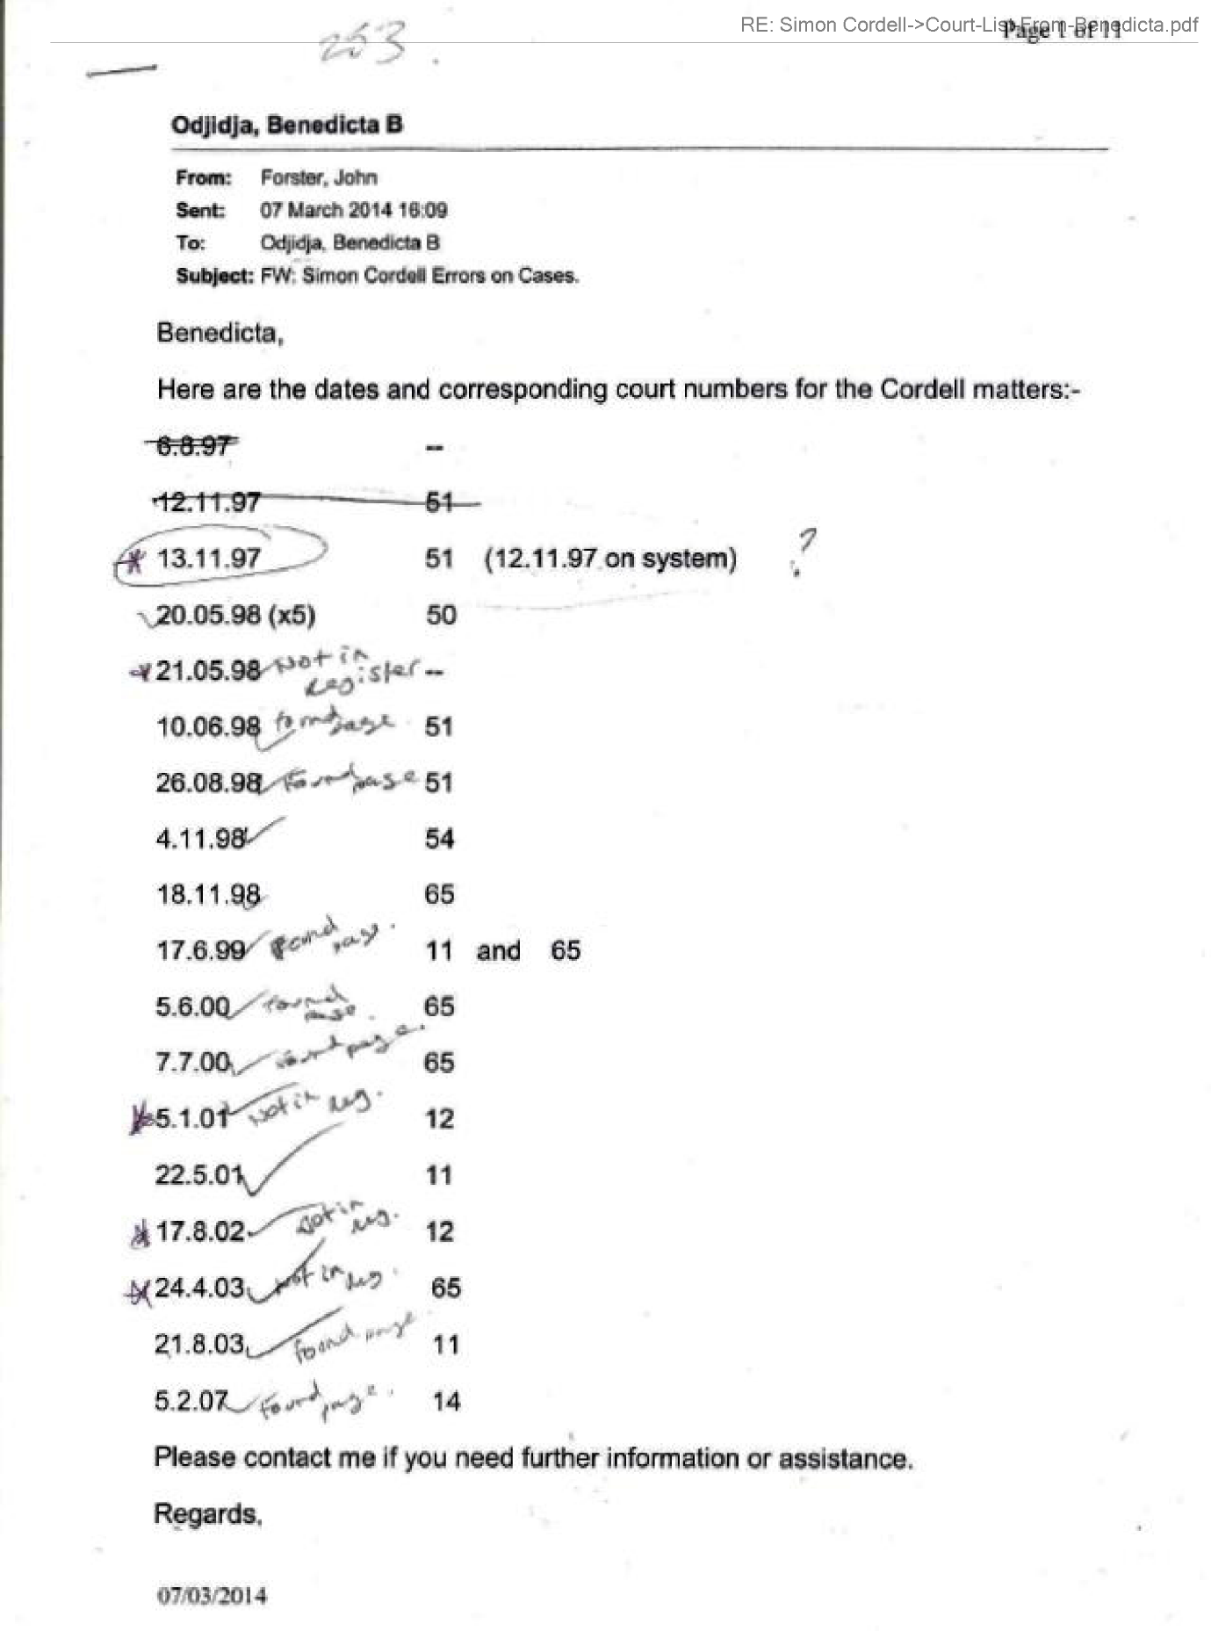  End of Picture!
13/03/2014 | 19.  Additional Email Attachments & Emails / Issue:  1. 19  lorraine32@blueyonder.co.uk_03.13.2014_RE Simon Cordell Errors on Cases. _002  13/03/2014  / Page Numbers: 127,128,129,130,131,132  133,134,135,136,137,138  139  --  127,  From: Lorraine Cordell <lorraine32@blueyonder.co.uk>  Sent: 13 March 2014 12:27  To: 'GL-HCORNERMCENQ'  Subject: RE: Simon Cordell Errors on Cases.  To Whom It May Concern:  I am sorry to keep emailing you, but I still have not had any emails with the data I have asked for. Can you please get back to me with what is going on?  Regards  Simon Cordell  18.  Additional Email Attachments & Emails / Issue:  1. 18  lorraine32@blueyonder.co.uk_03.13.2014_RE Simon Cordell Errors on Cases. _001  13/03/2014  / Page Numbers: 112,113,114  115,116,117,118,119,120  121,122,123,124,125,126  --  112,  From: Lorraine Cordell <lorraine32@blueyonder.co.uk>  Sent: 13 March 2014 13:12  To: 'GL-HCORNERMCENQ'  Subject: RE: Simon Cordell Errors on Cases.  To Whom It May Concern:  Could you please email them to this address if possible.  Regards Simon Cordell  From: GL-HCORNERMCENQ mailto: gl-hcornermcenq@hmcts.gsi.gov.uk  Sent: 13 March 2014 13:04  To: 'Lorraine Cordell'  Subject: RE: Simon Cordell Errors on Cases.  Dear Mr Cordell,  A number of the registers have been located and they are being copied now. We will send them by post tomorrow to the address given by you in a previous e-mail:  Mr. Simon Paul Cordell 109 Burncroft Road Enfield Middlesex EN3 7JQ  The age and quality of the register entries is such that scanning, and e-mailing is not a viable option. Regards,  Customer Services Unit  Highbury Corner Magistrates Court  Tel: 0207-506 3100  Fax: 0870 739 5768  e-mail: GL-HCORNERMCENQ@hmcts.gsi.gov.uk  I am neither authorised to bind the Ministry of Justice contractually, nor to make representations or other statements which may bind the Ministry of Justice in any way via electronic means.  113,  From: Lorraine Cordell mailto: lorraine32@blueyonder.co.uk  Sent: 13 March 2014 12:27  To: GL-HCORNERMCENQ  Subject: RE: Simon Cordell Errors on Cases.  To Whom It May Concern:  I am sorry to keep emailing you, but  114  115,116,117,118,119,120  121,122,123,124,125,126  17.  Additional Email Attachments & Emails / Issue:  1. 17  lorraine32@blueyonder.co.uk_03.13.2014_RE Simon Cordell Errors on Cases.  13/03/2014  / Page Numbers: 97,98,99,100,101,102  103,104,105,106,107,108  109,110,111  --  97,  From: Lorraine Cordell lorraine32@blueyonder.co.uk  Sent: 13 March 2014 14:10  To: gl-hcornermcenq@hmcts.gsi.gov.uk  Subject: RE: Simon Cordell Errors on Cases.  To Whom It May Concern:  Could you please email them to this address if possible? Or would it please be possible for my mum to attend Enfield Court and pick the data up.  Regards  Simon Cordell  From: GL-HCORNERMCENQ mailto: gl-hcornermcenq@hmcts.gsi.gov.uk  Sent: 13 March 2014 13:04  To: 'Lorraine Cordell'  Subject: RE: Simon Cordell Errors on Cases.  Dear Mr Cordell,  A number of the registers have been located  98,99,100,101,102  103,104,105,106,107,108  109,110,111
12/03/2014 | 16.  Additional Email Attachments & Emails / Issue:  1. 16  lorraine32@blueyonder.co.uk_03.12.2014_RE Simon Cordell Errors on Cases.  12/03/2014  / Page Numbers: 85,86,87,88,89,90  91,92,93,94,95,96  --  85,  From: Lorraine Cordell <lorraine32@blueyonder.co.uk>  Sent: 12 March 2014 11:59  To: GL-HCORNERMCENQ  Subject: RE: Simon Cordell Errors on Cases.  To Whom It May Concern:  I am writing this to see if there is any news as to the data I asked for. I was hoping to have got an email yesterday with some information due to the email you sent me on the 10/02/2014 but I did not. I understand that the court is only open Tuesday to Thursday which only give till tomorrow as you are aware, I am back in court on the 18/03/2014 which if I do not get anything by tomorrow, I will have to go into court then with nothing as the court would be closed. Could you therefore let me know if the data I have asked for will be available by tomorrow?  Regards  Simon Cordell  19.  Additional Email Attachments & Emails / Issue:  1. 19  lorraine32@blueyonder.co.uk_03.13.2014_RE Simon Cordell Errors on Cases. _002  13/03/2014  / Page Numbers: 127,128,129,130,131,132  133,134,135,136,137,138  139  --  127  From: GL-HCORNERMCENQ mailto: gl-hcornermcenq@hmcts.gsi.gov.uk  Sent: 12 March 2014 12:04  To: 'Lorraine Cordell'  Subject: RE: Simon Cordell Errors on Cases.  Dear Mr Cordell,  Our colleague is searching for the files now: I will send whatever she finds today. She will be continuing to search for files tomorrow also.  Regards,  Customer Services Unit  Highbury Corner Magistrates Court  Tel: 0207-506 3100  Fax: 0870 739 5768  e-mail: GL-HCORNERMCENQ@hmcts.gsi.gov.uk  I am neither authorised to bind the Ministry of Justice contractually, nor to make representations or other statements which may bind the Ministry of Justice in any way via electronic means.
10/03/2014 | 14.  Additional Email Attachments & Emails / Issue:  1. 14  lorraine32@blueyonder.co.uk_03.10.2014_RE Simon Cordell Errors on Cases.  10/03/2014  / Page Numbers: 72  73,74,75,76,77,78  79,80,81,82  --  72,  From: Lorraine Cordell lorraine32@blueyonder.co.uk  Sent: 10 March 2014 12:43  To: GL-HCORNERMCENQ  Subject: RE: Simon Cordell Errors on Cases.  To Whom It May Concern:  I am writing this email to see if there is any update to the information that I have asked for.  Regards Simon Cordell  19.  Additional Email Attachments & Emails / Issue:  1. 19  lorraine32@blueyonder.co.uk_03.13.2014_RE Simon Cordell Errors on Cases. _002  13/03/2014  / Page Numbers: 127,128,129,130,131,132  133,134,135,136,137,138  139  --  128  From: GL-HCORNERMCENQ mailto: gl-hcomermcenq@hmcts.gsi.gov.uk  Sent: 10 March 2014 12:59  To: 'Lorraine Cordell'  Subject: RE: Simon Cordell Errors on Cases.  Dear Mr Cordell,  As confirmed to Mrs Cordell last week, a member of staff at Tottenham Magistrates Court will research the Registers listed and copies will be sent, by e-mail, to you as we recover them. The Court opens Tuesday to Thursday: we hope to have at least some of the records for you tomorrow.  Regards,  Customer Services Unit  Highbury Corner Magistrates Court  Tel: 0207-506 3100  Fax: 0870 739 5768  e-mail: GL-HCORNERMCENQ@hmcts.gsi.gov.uk  I am neither authorised to bind the Ministry of Justice contractually, nor to make representations or other statements which may bind the Ministry of Justice in any way via electronic means.
06/03/2014 | 12.  Additional Email Attachments & Emails / Issue:  1.12  lorraine32@blueyonder.co.uk_03.06.2014_RE Simon Cordell Errors on Cases.  06/03/2014  / Page Numbers: 59,60  61,62,63,64,65,66  67,68  --  59,  From: Lorraine Cordell lorraine32@blueyonder.co.uk  Sent: 06 March 2014 09:38  To: 'GL-HCORNERMCENQ'  Subject: RE: Simon Cordell Errors on Cases.  To Whom It May Concern:  I am writing this to ask if there is any update, they did not list my case yesterday and it is now listed for today at Woolwich at 2pm so I was wondering if you had any of the data,  Simon Cordell
04/03/2014 | 12.  Additional Email Attachments & Emails / Issue:  1.12  lorraine32@blueyonder.co.uk_03.06.2014_RE Simon Cordell Errors on Cases.  06/03/2014  / Page Numbers: 59,60  61,62,63,64,65,66  67,68  --  59  From: GL-HCORNERMCENQ mailto: gl-hcornermcenq@hmcts.gsi.gov.uk  Sent: 04 March 2014 15:23  To: 'Lorraine Cordell'  Subject: RE: Simon Cordell Errors on Cases.  Dear Mr. Cordell,  Staff are looking for the records at Enfield Magistrates Court this week; however, we will not have them for tomorrow morning. We will endeavor to have as many as possible before Thursday. If there are specific dates you needed particularly, these could be accessed first.  Regards,  Customer Services Unit Highbury Corner Magistrates Court  Tel: 0207-506 3100  Fax: 0870 739 5768  e-mail: GL-HCORNERMCENQ@hmcts.gsi.gov.uk  I am neither authorised to bind the Ministry of Justice contractually, nor to make representations or other statements which may bind the Ministry of Justice in any way via electronic means.  From: Lorraine Cordell mailto: lorraine32@blueyonder.co.uk  Sent: 04 March 2014 15:08  To: GL-HCORNERMCENQ  Subject: RE: Simon Cordell Errors on Cases.  To Whom It May Concern:  I am wondering if there is any update, as I am in Woolwich Crown Court tomorrow and as said I wanted the information before I went to court.  60,  Regards  Simon Cordell
03/03/2014 | 12.  Additional Email Attachments & Emails / Issue:  1.12  lorraine32@blueyonder.co.uk_03.06.2014_RE Simon Cordell Errors on Cases.  06/03/2014  / Page Numbers: 59,60  61,62,63,64,65,66  67,68  --  60  From: Lorraine Cordell mailto: lorraine32@blueyonder.co.uk  Sent: 03 March 2014 14:39  To: 'GL-HCORNERMCENQ'  Subject: RE: Simon Cordell Errors on Cases.  To Whom It May Concern:  After your email dated the 21/02/2014 I was thinking that you would be searching for the data from the week of the 24/02/2014 as this is what it said in the email. As I said in my 1st email when asking for the information, I have a case that is at Woolwich crown court and I am having problems with my bail due to the records on my PNC, I am due in court maybe tomorrow or this week as my solicitor is putting into court to have a hearing and I wanted to have any errors on the PNC addressed at court.  Regards  Simon Cordell  From: GL-HCORNERMCENQ mailto: gl-hcornermcenq@hmcts.gsi.gov.uk  Sent: 03 March 2014 13:48  To: 'Lorraine Cordell'  Subject: RE: Simon Cordell Errors on Cases.  Dear Mr. Cordell,  Staff will be searching for the requested Registers from tomorrow. We will contact you as soon as this is done. Regards,  Customer Services Unit Highbury Corner Magistrates Court  Tel: 0207-506 3100  Fax: 0870 739 5768  e-mail: GL-HCORNERMCENQ@hmcts.gsi.gov.uk  I am neither authorised to bind the Ministry of Justice contractually, nor to make representations or other statements which may bind the Ministry of Justice in any way via electronic means.  From: Lorraine Cordell mailto: lorraine32@blueyonder.co.uk  Sent: 03 March 2014 13:22  To: GL-HCORNERMCENQ  Subject: RE: Simon Cordell Errors on Cases.  To Whom It May Concern:  I was wondering if there were any updates as to the data, I have asked for so that I can check cases against my PNC file.  61,  Regards  Simon Cordell
21/02/2014 | 12.  Additional Email Attachments & Emails / Issue:  1.12  lorraine32@blueyonder.co.uk_03.06.2014_RE Simon Cordell Errors on Cases.  06/03/2014  / Page Numbers: 59,60  61,62,63,64,65,66  67,68  --  61  From: GL-HCORNERMCENQ mailto: gl-hcornermcenq@hmcts.gsi.gov.uk  Sent: 21 February 2014 16:06  To: 'Lorraine Cordell'  Subject: RE: Simon Cordell Errors on Cases.  Dear Mr. Cordell,  The records you request are at another court. We will begin searching for them next week when the court is open. Regards,  Customer Services Unit Administration Officer Highbury Corner Magistrates Court  Tel: 0207-506 3100  Fax: 0870 739 5768  e-mail: gl-hcornermcenq@hmcts.gsi.gov.uk  I am neither authorised to bind the Ministry of Justice contractually, nor to make representations or other statements which may bind the Ministry of Justice in any way via electronic means.
20/02/2014 | 12.  Additional Email Attachments & Emails / Issue:  1.12  lorraine32@blueyonder.co.uk_03.06.2014_RE Simon Cordell Errors on Cases.  06/03/2014  / Page Numbers: 59,60  61,62,63,64,65,66  67,68  --  61  From: Lorraine Cordell mailto: lorraine32@blueyonder.co.uk  Sent: 20 February 2014 12:29  To: GL-HCORNERMCENQ  Subject: RE: Simon Cordell Errors on Cases.  Hello  I do understand that most of the items listed in my emails are archived due to their date but as I can see errors in the dates of some of the things and I know this as fact I would like all items checked that is listed so that it can be checked against the PNC records, I have got the printout from.  Many Thanks  Simon Cordell  From: GL-HCORNERMCENQ mailto: gl-hcornermcenq@hmcts.gsi.gov.uk  Sent: 20 February 2014 12:14  To: 'Lorraine Cordell'  Subject: RE: Simon Cordell Errors on Cases.  62,  Dear Mr. Cordell,  Further to the conversation between Mrs. Cordell and a member of staff yesterday, please specify which dates and offences you wish us to check. Almost all the offences are archived and not immediately accessible using the computer; specific dates and offences would help reduce the delay in providing this information.  Regards,  Customer Services Unit Administration Office Highbury Corner Magistrates Court  Tel: 0207-506 3100  Fax: 0870 739 5768  e-mail: GL-HCORNERMCENQ@hmcts.gsi.gov.uk  I am neither authorised to bind the Ministry of Justice contractually, nor to make representations or other statements which may bind the Ministry of Justice in any way via electronic means.
19/02/2014 | 19.  Additional Email Attachments & Emails / Issue:  1. 19  lorraine32@blueyonder.co.uk_03.13.2014_RE Simon Cordell Errors on Cases. _002  13/03/2014  / Page Numbers: 127,128,129,130,131,132  133,134,135,136,137,138  139,  --  132,  From: Lorraine Cordell mailto: lorraine32@blueyonder.co.uk  Sent: 19 February 2014 13:36  To: GL-HCORNERMCENQ  Subject: Re: Simon Cordell Errors on Cases.  Mr. Simon Paul Cordell 109 Burncroft Road Enfield Middlesex EN3 7JQ 18/02/2014  To Whom It May Concern:  I am writing this email as I have an ongoing case at Woolwich Crown Court, and I have noticed some errors in my PNC record which the police printed of at around 25/06/2013.  I would be very grateful if you can pull up the following records so I can check them with the PNC the police printed off for the case that is ongoing at Woolwich Crown Court, I have been told I will need a Memorandum of conviction or the transcript for the case.  I do know there are some errors on the cases that was heard at Enfield Magistrates and can see them clearly, but due to how far they go back cannot remember some of the cases. I do also know some are correct but due to some dates being wrong on some of the ones I can see errors in I would like to check all the cases on the PNC that was heard at Enfield Magistrates.  If this can be done as a matter of urgency due to the impact this is having on my life with the case that is ongoing at Woolwich Crown Court and my bail and other issues.  If the information could be emailed to me, I would be grateful as I am next in court on March 2014 and would like this information of any errors so I can show the judge.  Please see below the lists of cases I would like information on.  133,  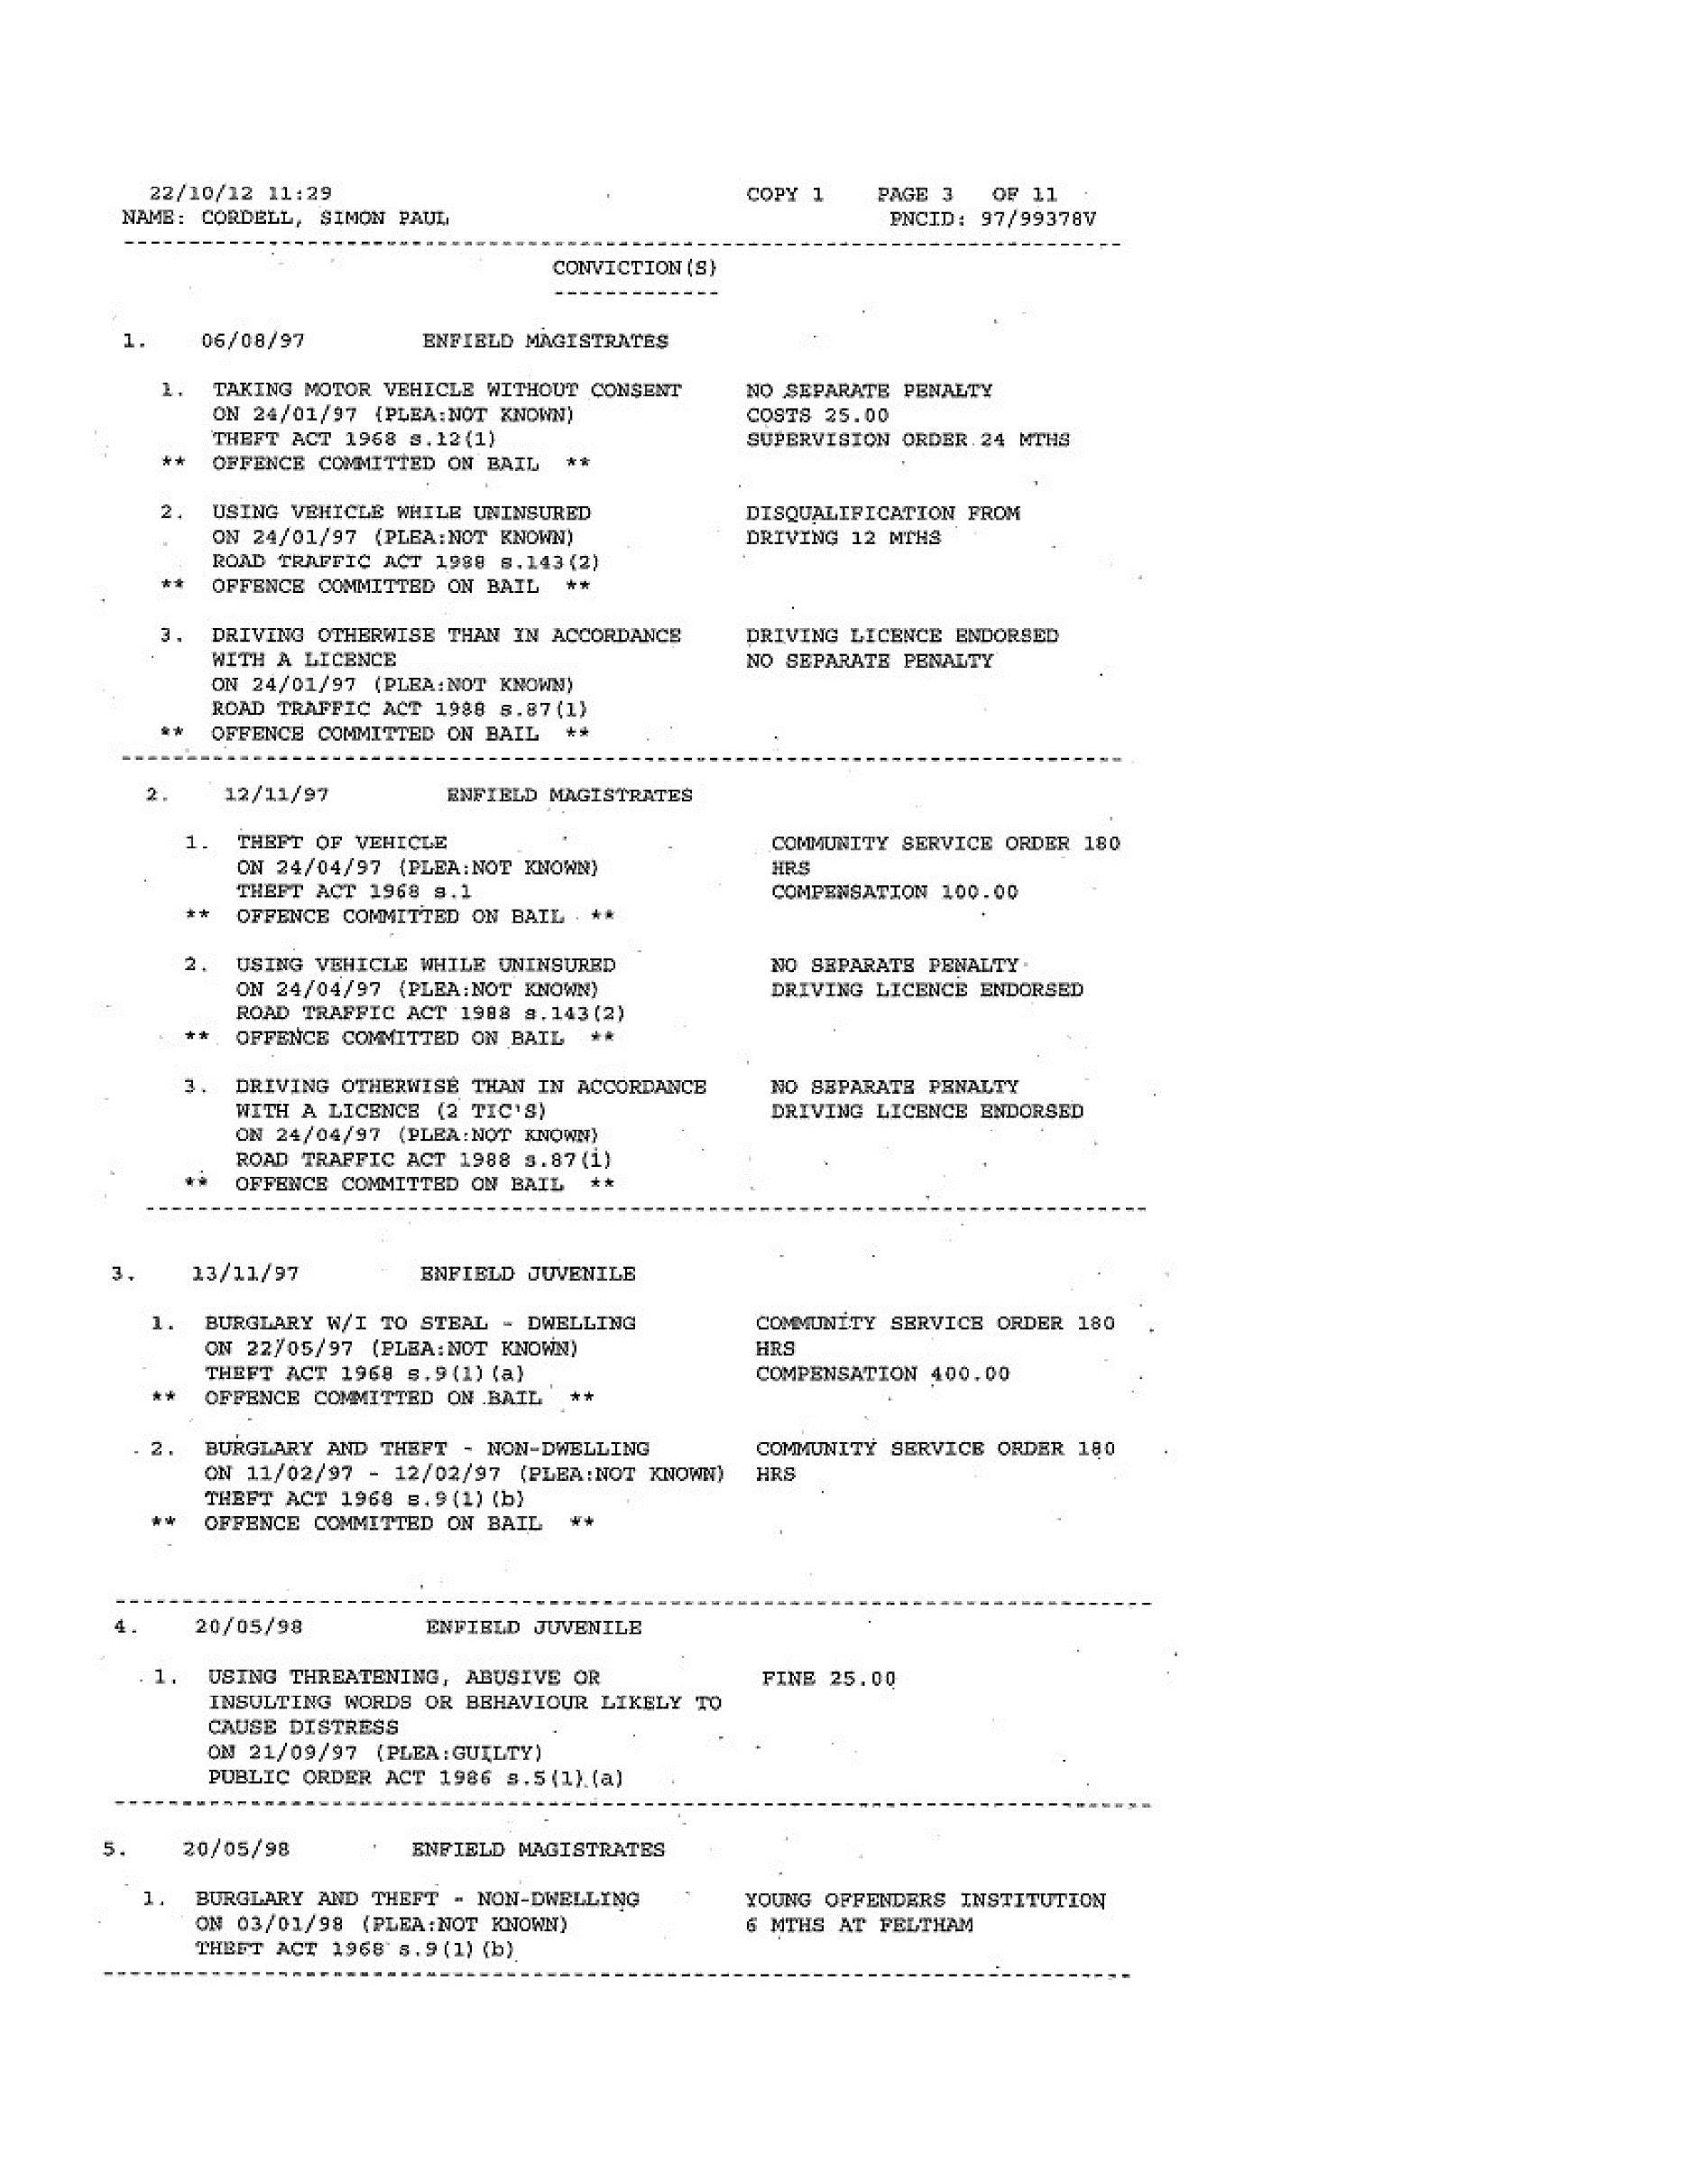  End of Picture!  134,  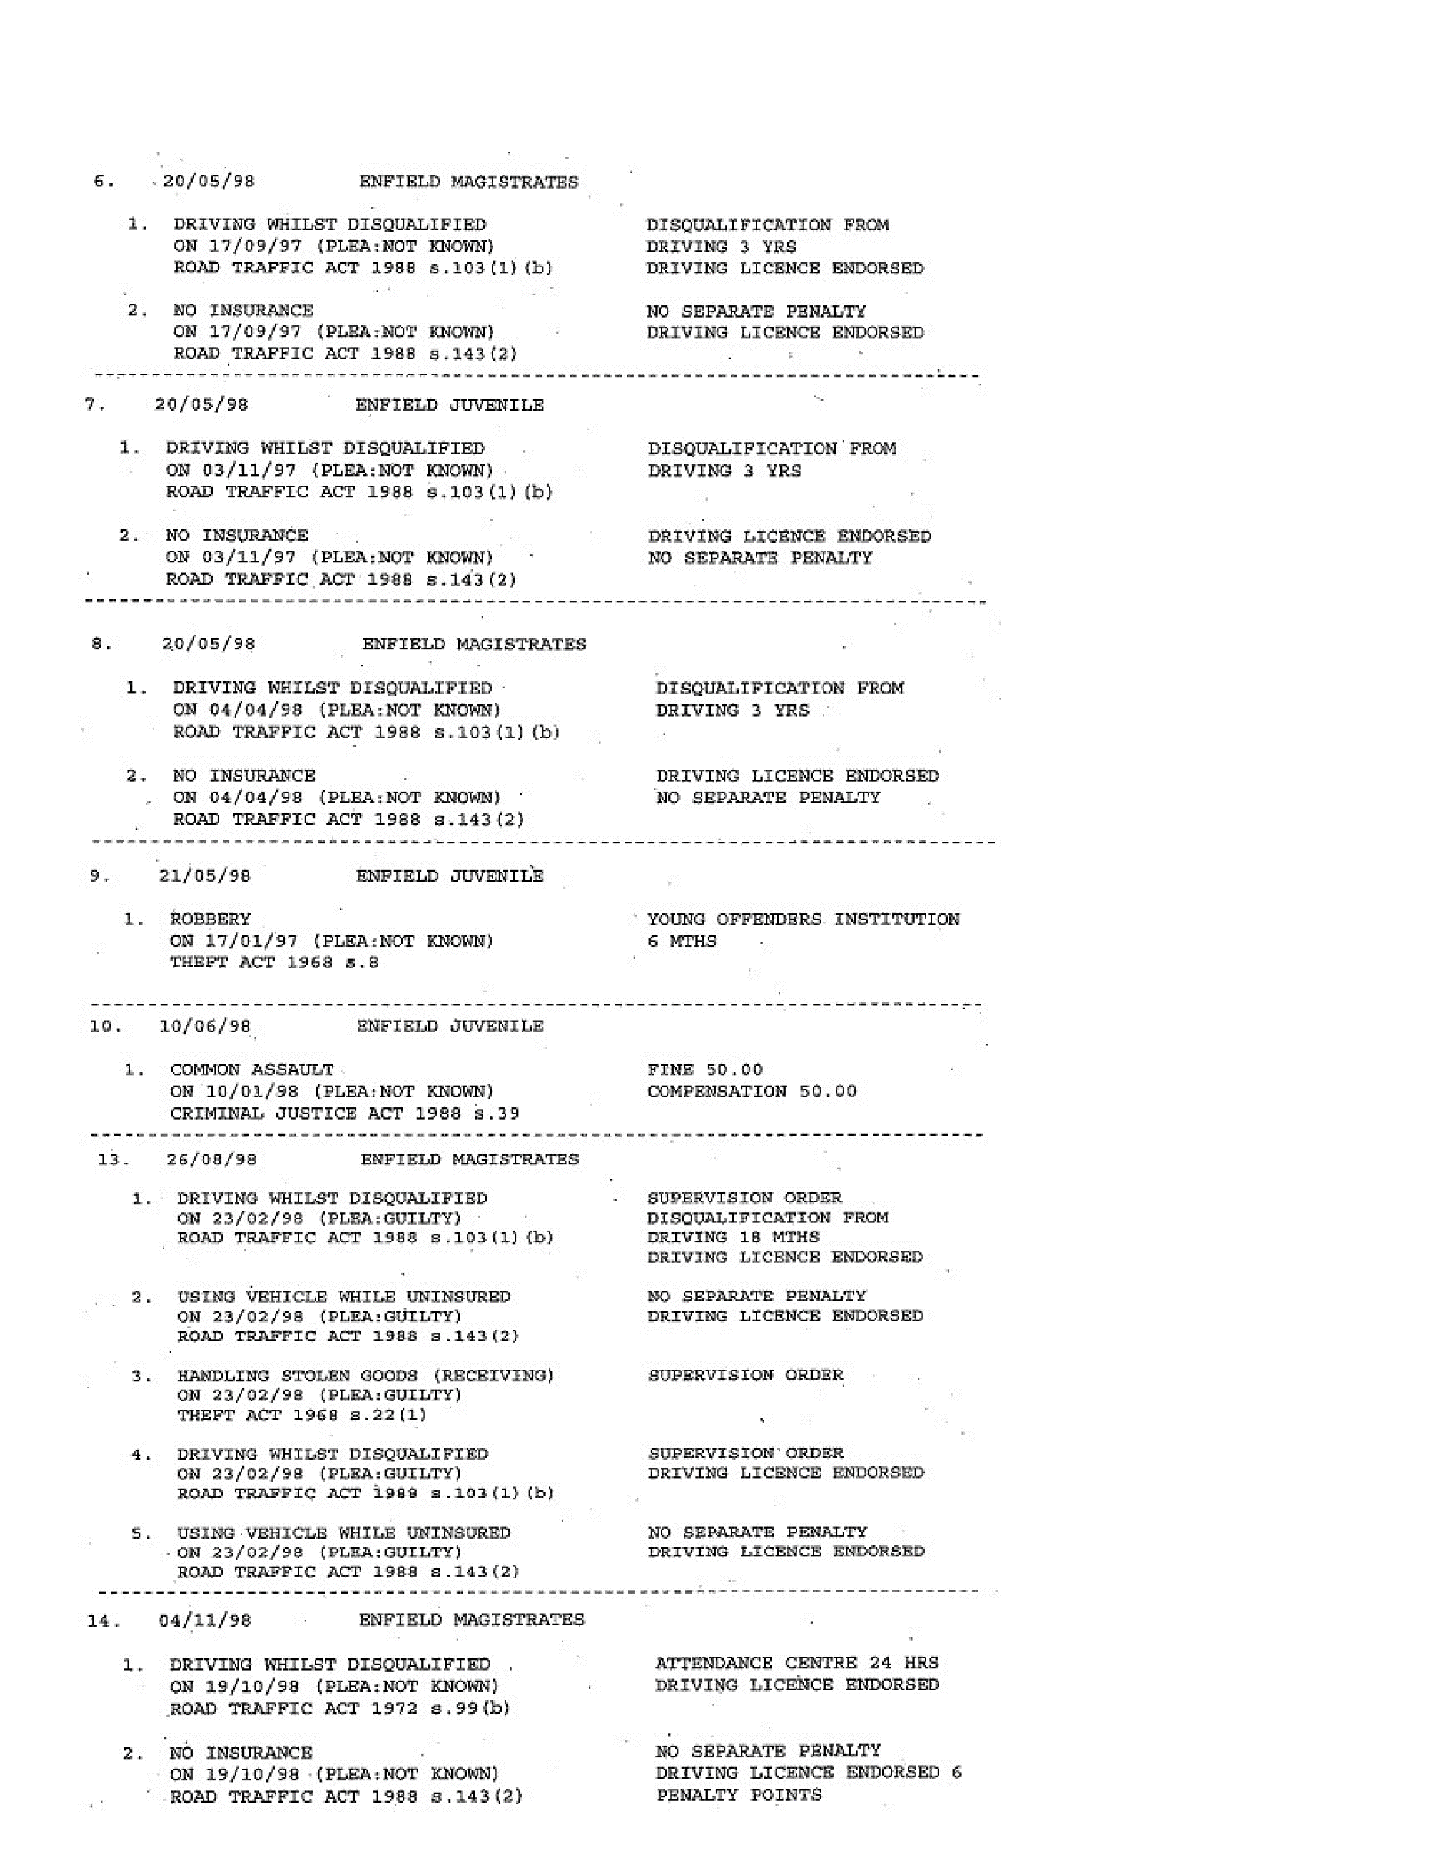  End of Picture!  135,  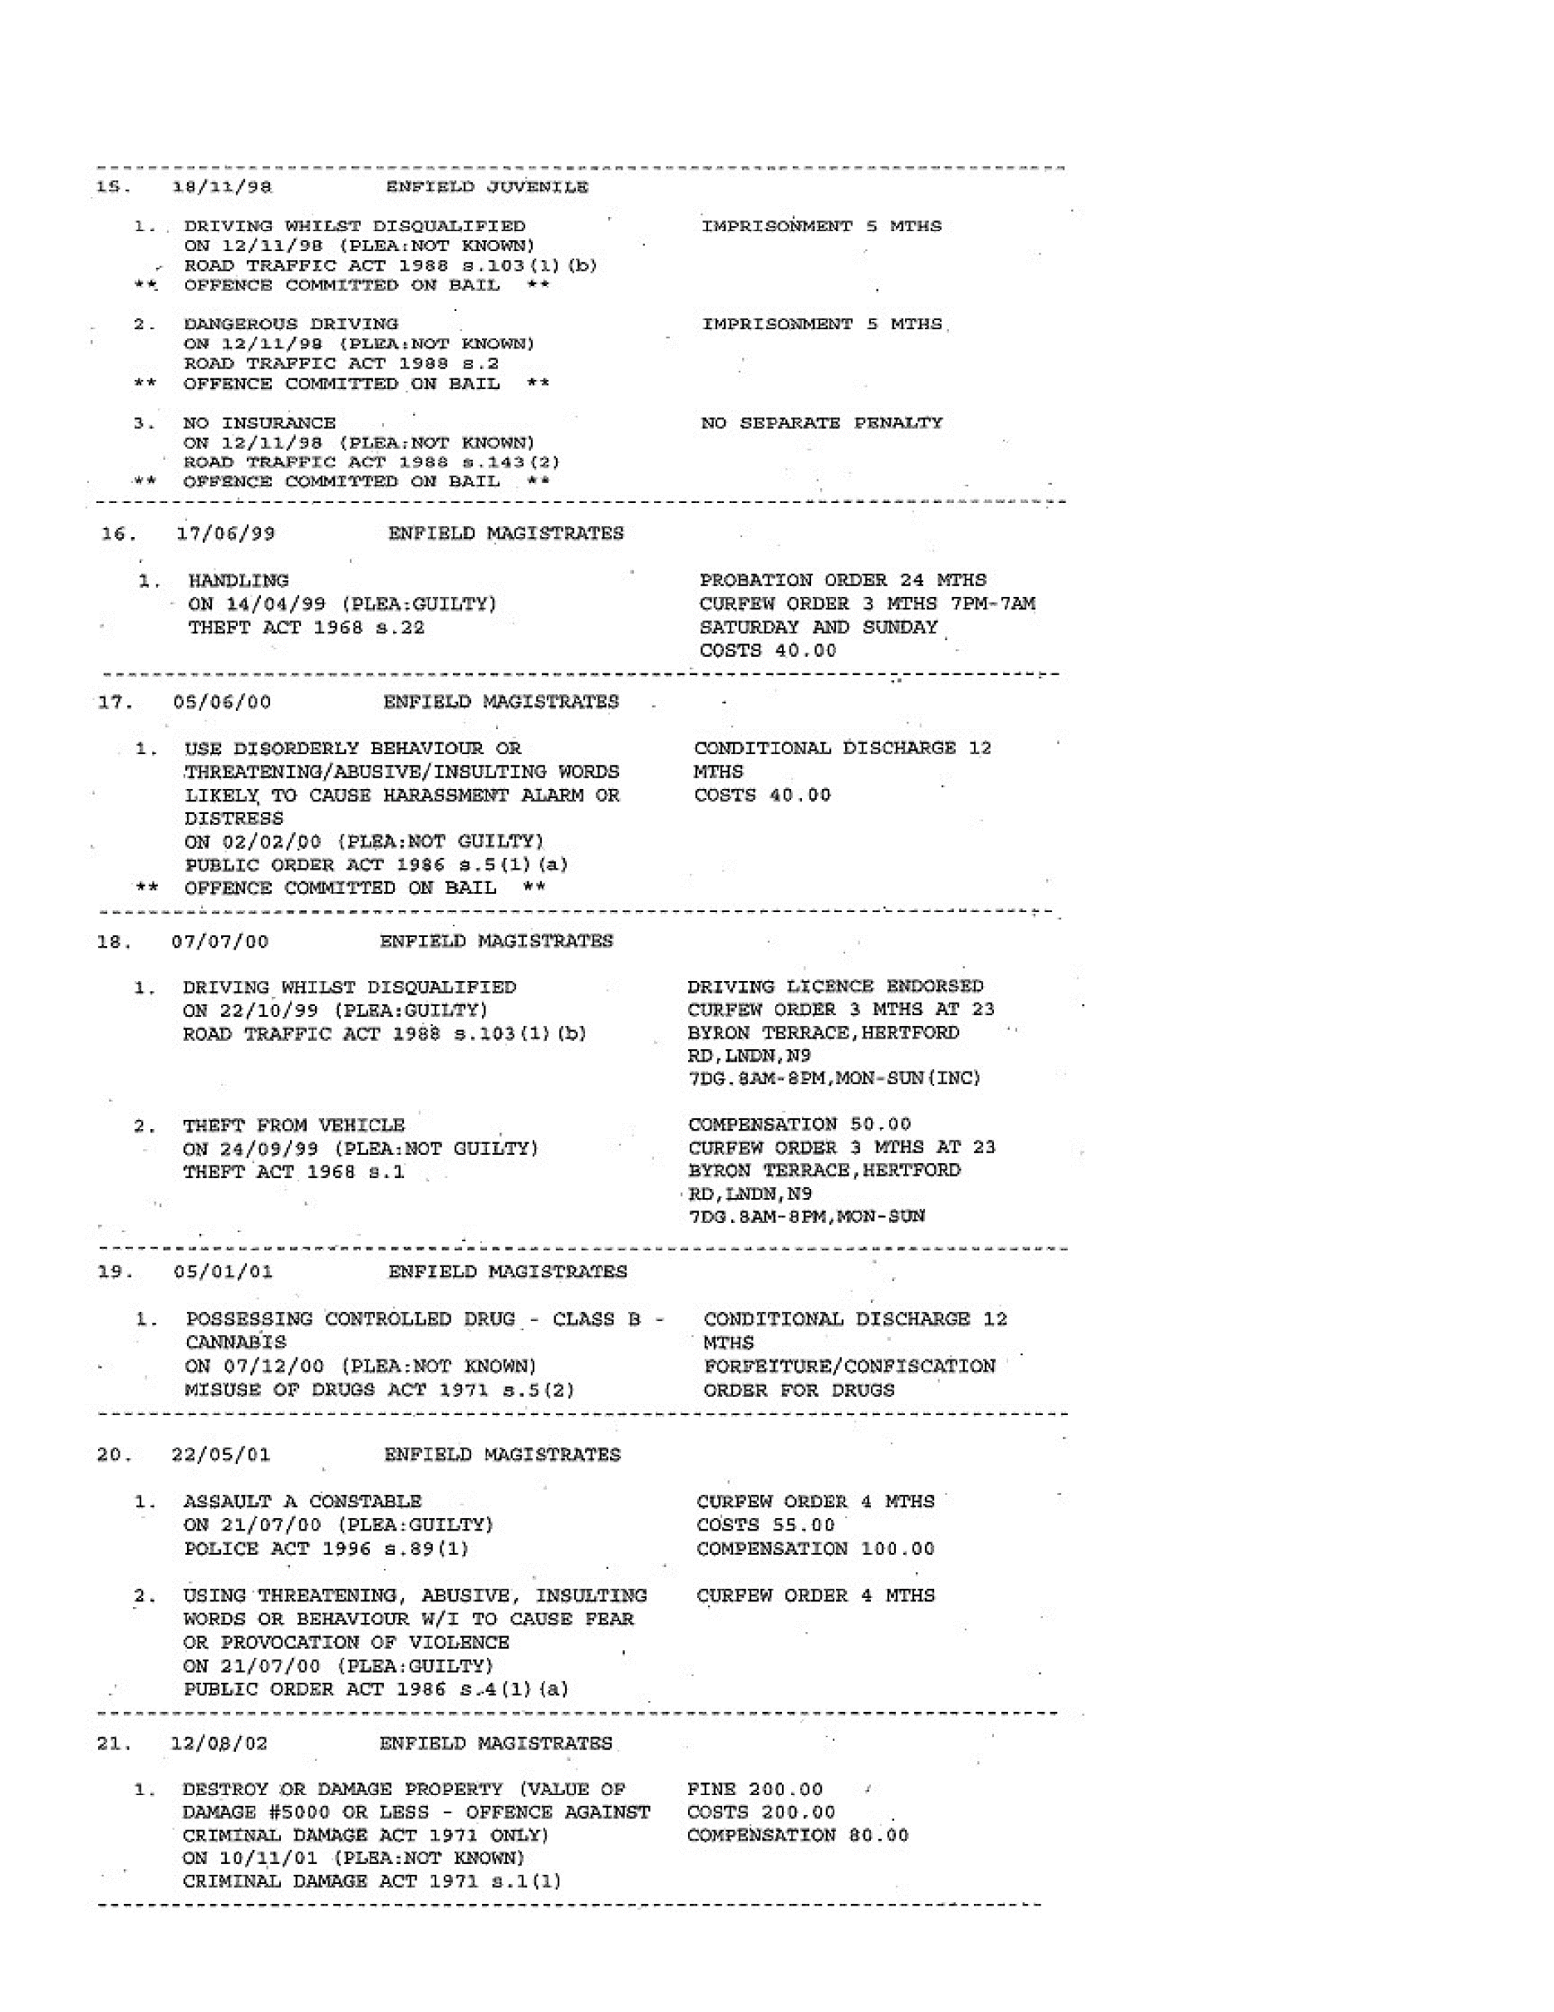  End of Picture!  136,  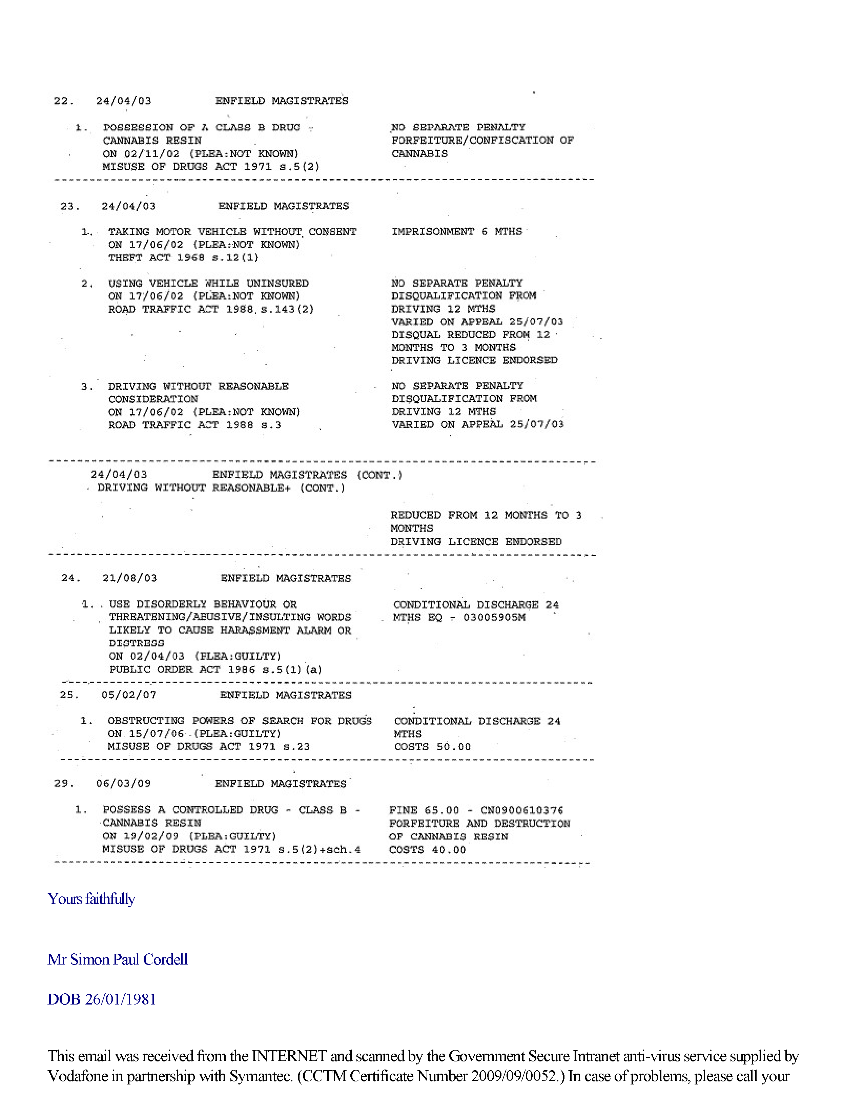  End of Picture!  137,  organization’s IT Helpdesk.  Communications via the GSi may be automatically logged, monitored and/or recorded for legal purposes.  This e-mail (and any attachment) is intended only for the attention of the addressee(s). Its unauthorised use, disclosure, storage, or copying is not permitted. If you are not the intended recipient, please destroy all copies and inform the sender by return e-mail.  Internet e-mail is not a secure medium. Any reply to this message could be intercepted and read by someone else. Please bear that in mind when deciding whether to send material in response to this message by e-mail.  This e-mail (whether you are the sender or the recipient) may be monitored, recorded, and retained by the Ministry of Justice. E-mail monitoring / blocking software may be used, and e-mail content may be read at any time. You have a responsibility to ensure laws are not broken when composing or forwarding e-mails and their contents.  The original of this email was scanned for viruses by the Government Secure Intranet virus scanning service supplied by Vodafone in partnership with Symantec. (CCTM Certificate Number 2009/09/0052.) On leaving the GSi this email was certified virus free. Communications via the GSi may be automatically logged, monitored and/or recorded for legal purposes.  This email was received from the INTERNET and scanned by the Government Secure Intranet anti-virus service supplied by Vodafone in partnership with Symantec. (CCTM Certificate Number 2009/09/0052.) In case of problems, please call your organisation's IT Helpdesk.  Communications via the GSi may be automatically logged, monitored and/or recorded for legal purposes.  This e-mail (and any attachment) is intended only for the attention of the addressee(s). Its unauthorised use, disclosure, storage, or copying is not permitted. If you are not the intended recipient, please destroy all copies and inform the sender by return e-mail.  Internet e-mail is not a secure medium. Any reply to this message could be intercepted and read by someone else. Please bear that in mind when deciding whether to send material in response to this message by e-mail.  This e-mail (whether you are the sender or the recipient) may be monitored, recorded, and retained by the Ministry of Justice. E-mail monitoring / blocking software may be used, and e-mail content may be read at any time. You have a responsibility to ensure laws are not broken when composing or forwarding e-mails and their contents.  The original of this email was scanned for viruses by the Government Secure Intranet virus scanning service supplied by Vodafone in partnership with Symantec. (CCTM Certificate Number 2009/09/0052.) On leaving the GSi this email was certified virus free. Communications via the GSi may be automatically logged, monitored and/or recorded for legal purposes.  This email was received from the INTERNET and scanned by the Government Secure Intranet anti-virus service supplied by  138,  Vodafone in partnership with Symantec. (CCTM Certificate Number 2009/09/0052.) In case of problems, please call your organisation's IT Helpdesk.  Communications via the GSi may be automatically logged, monitored and/or recorded for legal purposes.  This e-mail (and any attachment) is intended only for the attention of the addressee(s). Its unauthorised use, disclosure, storage, or copying is not permitted. If you are not the intended recipient, please destroy all copies and inform the sender by return e-mail.  Internet e-mail is not a secure medium. Any reply to this message could be intercepted and read by someone else. Please bear that in mind when deciding whether to send material in response to this message by e-mail.  This e-mail (whether you are the sender or the recipient) may be monitored, recorded, and retained by the Ministry of Justice. E-mail monitoring / blocking software may be used, and e-mail content may be read at any time. You have a responsibility to ensure laws are not broken when composing or forwarding e-mails and their contents.  The original of this email was scanned for viruses by the Government Secure Intranet virus scanning service supplied by Vodafone in partnership with Symantec. (CCTM Certificate Number 2009/09/0052.) On leaving the GSi this email was certified virus free. Communications via the GSi may be automatically logged, monitored and/or recorded for legal purposes.  This email was received from the INTERNET and scanned by the Government Secure Intranet anti-virus service supplied by Vodafone in partnership with Symantec. (CCTM Certificate Number 2009/09/0052.) In case of problems, please call your organisation's IT Helpdesk.  Communications via the GSi may be automatically logged, monitored and/or recorded for legal purposes.  This e-mail (and any attachment) is intended only for the attention of the addressee(s). Its unauthorised use, disclosure, storage, or copying is not permitted. If you are not the intended recipient, please destroy all copies and inform the sender by return e-mail.  Internet e-mail is not a secure medium. Any reply to this message could be intercepted and read by someone else. Please bear that in mind when deciding whether to send material in response to this message by e-mail.  This e-mail (whether you are the sender or the recipient) may be monitored, recorded, and retained by the Ministry of Justice. E-mail monitoring / blocking software may be used, and e-mail content may be read at any time. You have a responsibility to ensure laws are not broken when composing or forwarding e-mails and their contents.  The original of this email was scanned for viruses by the Government Secure Intranet virus scanning service supplied by Vodafone in partnership with Symantec. (CCTM Certificate Number 2009/09/0052.) On leaving the GSi this email was certified virus free. Communications via the GSi may be automatically logged, monitored and/or recorded for legal purposes.  139,  This email was received from the INTERNET and scanned by the Government Secure Intranet anti-virus service supplied by Vodafone in partnership with Symantec. (CCTM Certificate Number 2009/09/0052.) In case of problems, please call your organisation's IT Helpdesk.  Communications via the GSi may be automatically logged, monitored and/or recorded for legal purposes.  This e-mail (and any attachment) is intended only for the attention of the addressee(s). Its unauthorised use, disclosure, storage, or copying is not permitted. If you are not the intended recipient, please destroy all copies and inform the sender by return e-mail.  Internet e-mail is not a secure medium. Any reply to this message could be intercepted and read by someone else. Please bear that in mind when deciding whether to send material in response to this message by e-mail.  This e-mail (whether you are the sender or the recipient) may be monitored, recorded, and retained by the Ministry of Justice. E-mail monitoring / blocking software may be used, and e-mail content may be read at any time. You have a responsibility to ensure laws are not broken when composing or forwarding e-mails and their contents.  The original of this email was scanned for viruses by the Government Secure Intranet virus scanning service supplied by Vodafone in partnership with Symantec. (CCTM Certificate Number 2009/09/0052.) On leaving the GSi this email was certified virus free. Communications via the GSi may be automatically logged, monitored and/or recorded for legal purposes.  This email was received from the INTERNET and scanned by the Government Secure Intranet anti-virus service supplied by Vodafone in partnership with Symantec. (CCTM Certificate Number 2009/09/0052.) In case of problems, please call your organisation's IT Helpdesk.  Communications via the GSi may be automatically logged, monitored and/or recorded for legal purposes.  This e-mail (and any attachment) is intended only for the attention of the addressee(s). Its unauthorised use, disclosure, storage, or copying is not permitted. If you are not the intended recipient, please destroy all copies and inform the sender by return e-mail.  Internet e-mail is not a secure medium. Any reply to this message could be intercepted and read by someone else. Please bear that in mind when deciding whether to send material in response to this message by e-mail.  This e-mail (whether you are the sender or the recipient) may be monitored, recorded, and retained by the Ministry of Justice. E-mail monitoring / blocking software may be used, and e-mail content may be read at any time. You have a responsibility to ensure laws are not broken when composing or forwarding e-mails and their contents.  The original of this email was scanned for viruses by the Government Secure Intranet virus scanning service supplied by Vodafone in partnership with Symantec. (CCTM Certificate Number 2009/09/0052.) On leaving the GSi this email was certified virus free. Communications via the GSi may be automatically logged, monitored and/or recorded for legal purposes.

